Nic Falcione

CPSC 498

2/25/2020

Weekly Update #3

1. What progress have you made since the last meeting, including specific items that were completed, and the time spent on each item?

I have verified the connectivity to my database and populated multiple schemas, including one representing Computer Science and AOI classes. I resolved a bug where I was missing a public subnet for my AWS RDS in the right availability zone. I spent about 6 hours completing all these tasks.

1. What progress you expect to make in the upcoming week, including specific items, and time estimates on how much time you will spend on them?

I plan on finishing the database schemas for the other PCSE majors to represent the courses and requirements for each major. I also plan on developing a homepage for my webpage and pushing it to my AWS EC2 instance. I imagine these task will take about 6-7 hours.

1. Any changes you have identified that will result in your final project being different than your project proposal. This information must be recorded in 3 ways.

I do not have any changes planned for my final project that differ from my project proposal.

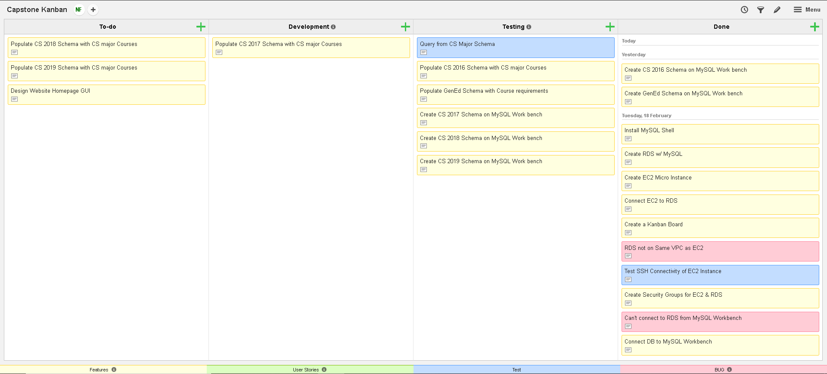

Figure 1: Snapshot of Kanban Board